Università degli Studi di Padova - DiSLL
Lingue Moderne per la Comunicazione e la Cooperazione Internazionale

Traduzione specializzata di inglese 1 – Continuous assessment test
07.06.2019

Popular science text

The Economist

Never too old

Measles is often spread by adults
Vaccinating children only is no longer enough

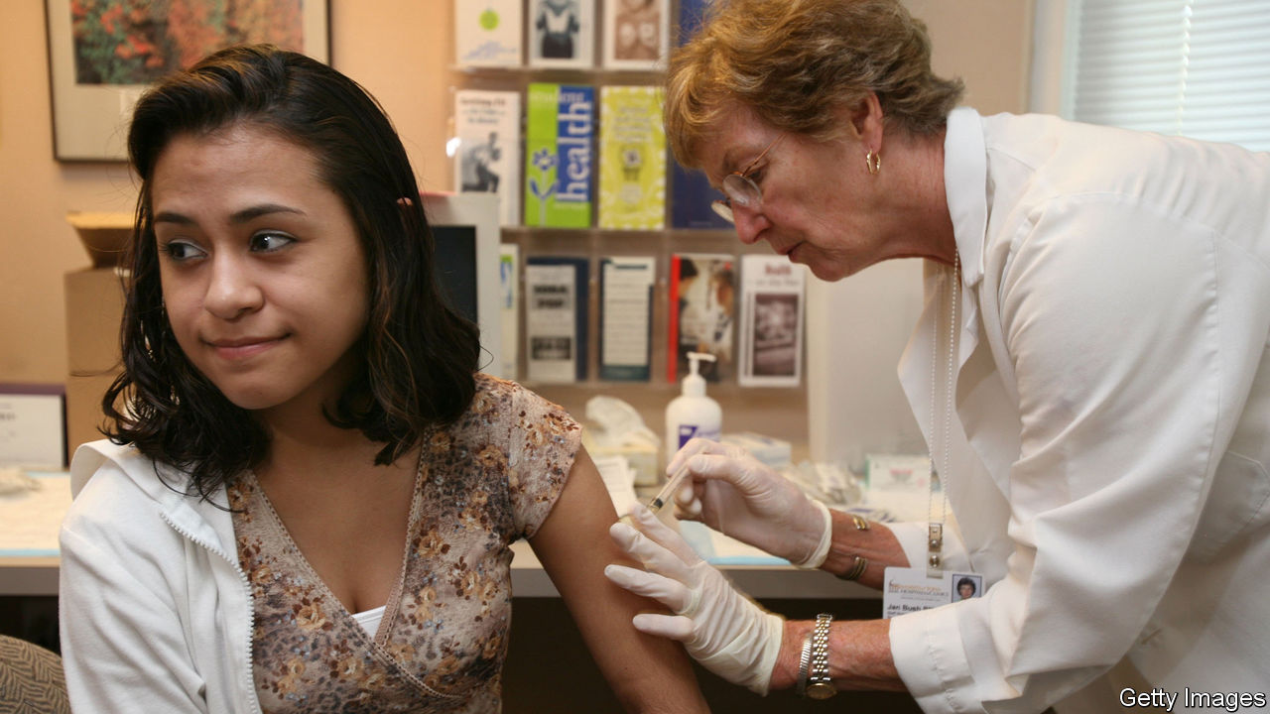

Print edition | Science and technology
May 25th 2019
In recent years, measles outbreaks have become more frequent, with no signs of abating. The resurgence has been blamed on parents refusing to vaccinate their children or delaying jabs. But what has also become clear is that vaccinating only children is no longer sufficient. In 2013-17 between 33% and 63% of the annual measles cases in Europe were among people older than 14 years. In 2017 the median age for measles cases in Italy, which has frequent outbreaks, was 27 years.
A paper published in Science this month shows how this pattern evolved. Using historical data and statistical modelling, the paper’s authors find that as a country gets closer to fully eliminating measles, the age range of those who are not immune to the disease widens. Catch-up jabs, in other words, need to cover older and older groups of people.
The main reason for this is the accumulation over time of people who missed one or both of the two measles jabs that are routine for children. At the same time, falling birth rates have led to fewer and fewer babies, who are susceptible to measles until they are old enough to be vaccinated. As a result, the average age of susceptible people has crept up.

- Translate the text into Italian for publication in Internazionale. Consider whether the image is suitable for the target language publication. If not, you can suggest an alternative image.
- Comment on your chosen translation of at least two of the following phrases, clauses or sentences: a. with no signs of abating; b. The resurgence has been blamed on parents; c. In 2017 the median age for measles cases in Italy …; d. Catch-up jabs, in other words, need to cover older and older groups of people; e. As a result, the average age of susceptible people has crept up. Supply references to all the websites you looked up. Please remember that you cannot quote Reverso, Linguee and Wordreference to support any of your choices.
- Using the template below, create a terminology entry for one of the following terms in the text: outbreak, jab, catch-up jab. Supply references to all the texts, websites etc. you looked up. Please remember no contexts can be taken from translated texts, encyclopaedias or dictionaries and that Reverso, Linguee and Wordreference cannot be used to support any choice.
**
<Subject>medicine/medicina
<Subfield>vaccination/vaccinazioni
<it>iniezione di richiamo
<Morphosyntax>noun group, f.
<Source>^short reference + date^ [date = year]
<Usage label>main term
<Definition>xxxxx.
<Source> ^short reference + date^
<Context>Example of use including the term.
<Source>^xxxx^
<Concept field>concetti generali
<Related words>^iniezione ipodermica^
<Type of relation>super.
<Synonyms>Comment on the degree of synonymy.
<Equivalence it-en>Tra il termine italiano “iniezione di richiamo” e il termine inglese “catch-up jab” esiste piena identità concettuale.

<it>richiamo
<Morphosyntax>m.
<Source>^xxx^
<Category>short form
<Context>Example of use including the term.
<Source>^short reference + date^

<en>catch-up injection
<Morphosyntax>noun group
<Usage label>main term
<Source>^short reference + date^
<Definition>xxx
<Source>^short reference + date^
<Context> Example of use including the term.
<Source>^short reference + date^
<Concept field>general concepts
<Related words>^hypodermic injection^
<Type of relation>super.
<Synonyms> Comment on the degree of synonymy.

<en>catch-up jab
<Morphosyntax>noun group
<Source>^short reference + date^
<Style label>informal
<Context> Example of use including the term.
<Source>^short reference + date^
**
<source>short reference + date
<Reference>Author (date = year) “Article title”, place of publication, publisher, pages.
**
<source>short reference + date
<Reference>Smith A. (date=year) Book title, place of publication, publisher.
**
<source> short reference + date
<Reference>Author (date =year), “Article title”, web address (last accessed in June 2019).
**

Technology text

How to design your dream kitchen
People use their kitchen in different ways depending on the amount of space they have to play with and their individual lifestyle. However, there are a few basic guidelines that apply to any kitchen design and will provide the groundwork for designing the perfect kitchen.
Begin by separating your kitchen into different zones for cooking, food preparation and washing. Your cooking zone includes your oven, hob or range cooker, an extractor fan and a microwave if you have one. Make sure this area is not in the pathway to a door or blocking the main thoroughfare through the room – handling hot cookware while people are trying to walk past you is a recipe for disaster.
Other things to consider include leaving enough space next to the hob for setting down pans, allocating an area for serving up dishes, and making sure there is enough space in front of the oven for the door to open unhindered - a minimum of half a metre is a must.
The work zone is where will have your fridge-freeze as well as your kitchen sink, dishwasher and kitchen waste bin - these should all be as close together as possible so you can tip leftover food into the bin, rinse the plates then stack them in the dishwasher with minimum effort.
Read more at https://www.idealhome.co.uk/kitchens#AAWWPhtbGyEcsijS.99
- Translate the text into Italian for publication on the Italian version of the magazine website. Consider whether the image is suitable for the target language publication. If not, you can suggest an alternative image.
- Comment on your chosen translation of at least two of the following phrases, clauses or sentences: a. depending on the amount of space they have to play with; b. the groundwork for designing the perfect kitchen; c. handling hot cookware … is a recipe for disaster; d. Other things to consider include leaving enough space next to the hob; e. these should all be as close together as possible so you can tip leftover food into the bin. the texts, websites etc. you looked up. Please remember that you cannot quote Reverso, Linguee and Wordreference to support any of your choices.
- Using the template below, create a terminology entry for one of the following terms in the text: hob, oven, range cooker, extractor fan or microwave. Supply references to all the texts, websites etc. you looked up. Please remember no contexts can be taken from translated texts, encyclopaedias or dictionaries and that Reverso, Linguee and Wordreference cannot be used to support any choice.
**
<Subject>furniture and appliances/mobili ed elettrodomestici
<Subfield>kitchen furniture and appliances/mobile ed elettrodomestici da cucina
<it>piano cottura
<Morphosyntax>noun group, m.
<Source>^short reference + date^ [date = year]
<Usage label>main term
<Definition>xxxxx.
<Source> ^short reference + date^
<Context>Example of use including the term.
<Source>^xxxx^
<Concept field>concetti generali
<Related words>^elettrodomestici da cucina^
<Type of relation>super.
<Related words>^forno^, ^blocco cottura^, ^cappa aspiratrice^, ^forno a microonde^
<Synonyms>Comment on the degree of synonymy.
<Equivalence it-en>Tra il termine italiano “piano cottura” e il termine inglese “catch-up jab” esiste piena identità concettuale.

<it>fornello
<Morphosyntax>m.
<Source>^xxx^
<Usage label>informal
<Context>Example of use including the term.
<Source>^short reference + date^

<en>hob
<Morphosyntax>noun
<Usage label>main term
<Source>^short reference + date^
<Category>short form
<Definition>xxx
<Source>^short reference + date^
<Context> Example of use including the term.
<Source>^short reference + date^
<Concept field>general concepts
<Related words>^kitchen appliances^
<Type of relation>super.
<Related words>^oven^, ^range cooker^, ^extractor fan^, ^microwave^
<Synonyms>Comment on the degree of synonymy.

<en>kitchen hob
<Morphosyntax>noun group
<Source>^short reference + date^
<Category>full form
<Context> Example of use including the term.
<Source>^short reference + date^
**
<source>short reference + date
<Reference>Author (date = year) “Article title”, place of publication, publisher, pages.
**
<source>short reference + date
<Reference>Smith A. (date=year) Book title, place of publication, publisher.
**
<source> short reference + date
<Reference>Author (date =year), “Article title”, web address (last accessed in June 2019).
**

