**Thesis and Graduation Guidelines - ASCH 2024/25**

**GENERAL INFORMATION**

Students are expected to choose a supervisor (a member of the ASCH teaching staff), proposing a subject (thesis topics inspiration: our [moodle](https://ssu.elearning.unipd.it/course/view.php?id=9796) page). Upon agreeing with the supervisor on the topic and deadlines, students must register for the final exam/graduation via **Uniweb**. Students are required to write an original dissertation, under the guidance of the chosen supervisor. The dissertation shall be written entirely in English, but an extended summary is required in Italian as well. Regarding the graduation day, the dissertation shall be discussed before a Committee. The discussion will be held in English. We recommend students who fail to finish their thesis on time, to promptly cancel the registration (see <https://www.unipd.it/en/graduation> “How to change your application” section).

-Manual for thesis upload procedure ([2022 version, in Italian](https://www.unipd.it/sites/unipd.it/files/2022/uniweb_domanda_di_laurea_new%2014_04_2022.pdf))

**THESIS DISCUSSION**

For the day of the discussion, you will have to prepare a 15 minute (max.) presentation of your work, that can be supported by slides. After your presentation, the Committee and your supervisor will ask you a couple of questions. The discussion will last 10 to 15 minutes. As this part is finished, you will be asked to exit the room so that the jury will be able to discuss your grade and then you will be called back in the room for the proclamation; the Commission will announce your vote and announce your graduation in Archaeological Sciences (this part is in Italian).

**WHEN?**

##### [Course: Master’s Degrees Calendars - dBC | Moodle Scienze umane (unipd.it)](https://ssu.elearning.unipd.it/course/view.php?id=14754&lang=en)

##### 

##### Final examination schedule:

Please find at [this link](https://ssu.elearning.unipd.it/mod/page/view.php?id=345617&lang=en) the official list of undergraduates and graduation schedule in dBC.

**Deadlines AY 2023/2024**

|  |
| --- |
| THIRD PERIOD B |
| ONLY CALL: 2 - 14 DECEMBER 2024  Application (uniweb): from 19/08/2024 to 08/10/2024  Last day for taking exams: 15/11/2024  Thesis deadline: November 20th, 2024 |
|

**Deadlines AY 2024/2025**

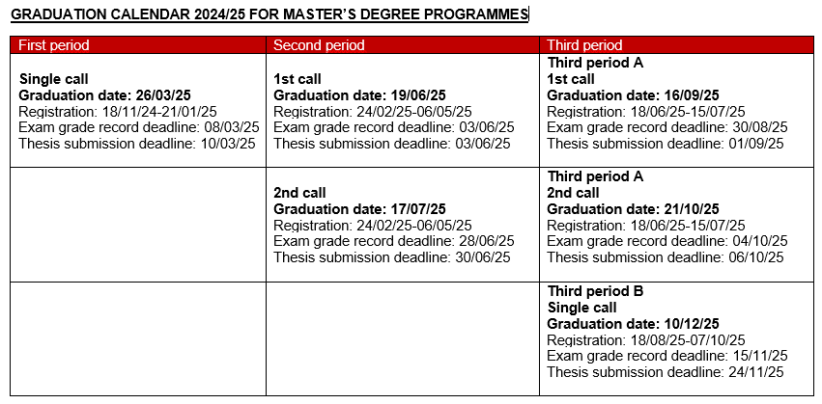

*This is an adaptation, for ASCH students only, of the official Graduation Calendar provided by the School of Human Sciences and available [at this link](https://ssu.elearning.unipd.it/mod/page/view.php?id=345617).

Students must carefully evaluate for which call they should register considering their career status (exams, laboratories, thesis).

##### **FEES PAYMENT**

All enrolment fees must be paid before starting the graduation procedure. Please check that you have followed the [payment procedures](https://www.unipd.it/en/tuition-fees) correctly.

**THESIS FORMAT**

Find the template for the title page of the Master Degree in Applied Sciences to Cultural Heritage Materials and Sites a.a. 2024/2025 at the moodle page of the course.

The final file of the thesis should:

-be in PDF/A format;

-have a maximum size of 40 MegaBytes;

-the file name should follow the following standard: Last_Name.pdf (e.g. Rossi_Mario.pdf).

## **FAQ**

1. *How should the thesis be written?*

The thesis must be written and discussed in English.

For all details regarding structure, format, etc. please see the Guidelines or talk to your supervisor.

1. *Can the student choose a professor who is not a member of the degree program as a supervisor?*

Yes, as long as the professor is a professor at the University of Padua and upon authorization of the Coordinator of the Master’s in Applied Sciences to Cultural Heritage Materials and Sites. Please always ask prof. Artioli in advance.

1. *Can the student choose a retired/visiting professor as a supervisor?*

Yes. In this case, the external professor has to be flanked by a professor related to the degree program who acts as the main supervisor, i.e. the student must have two supervisors.

1. *When and where is the calendar of the “discussions” published?*

The calendar of the “discussions” (presentation of the thesis) and other useful details are published about 10 days before the call (see calendar) on the Department's website.

1. *Which grade can be awarded to the final exam?*

The final degree is the weighted average of grades obtained for exams + the points obtained for the final exam.

The Committee will assign 1 to 5 points for the thesis defense.

The scale of the final mark is 110. Cum Laude is awarded at the Committee's discretion to students who achieve at least 110/110 and have had at least one exam marked as 30L in their record.

**TIPS**

-Do not wait until the deadline to upload your thesis. Try doing it at least a week in advance.

-When you upload the file on pdf, no message or notification will arrive to you. If you are able to see the attachment on Uniweb, then it must be uploaded. Your supervisor will approve it soon.

-Time management is certainly an important skill to develop during the writing process. Keeping a timetable is warmly suggested. Define precisely what you have to do in terms of tasks. Be realistic.

**IMPORTANT:** In order to graduate, students must have completed and registered all exams in their study plans at least 15 days prior to the start date of the graduation exam session.

Remember that:

-the Almalaurea questionnaire must also be completed online;

-at the confirmation step of the procedure, you will receive a payment request via Uniweb to be paid within 24 hours.

We recommend students who fail to finish their thesis on time, to promptly cancel the registration (see <https://www.unipd.it/en/graduation> “How to change your application” section).

### [**Dissertation tips**](https://ssu.elearning.unipd.it/course/view.php?id=9796&section=3)

#### **A few tips for selecting the thesis topic and tutors**

1) Preferentially, you should select the topic and the tutors proposed in the list found on moodle, because they are available and they have been discussed between teachers.

2) if you are thinking about a specific topic that it is not included, please discuss the feasibility and timing in detail with the appropriate teacher(s) of the courses of the ASCH master

3) if you wish to work with other teachers or scientist not directly involved in the ASCH courses, they must necessarily contact one of the teacher and discuss the details of the activities, because you must have an internal tutor of the ASCH course

#### **A few tips for planning and completing the dissertation.**

1) Remember that you need to **register for graduation**, within the deadlines set up for each graduation period**(**[**https://www.unipd.it/en/graduation**](https://www.unipd.it/en/graduation)), communicating the name(s) of the tutor(s) and the final title of the Dissertation.

2) At the same time, you should communicate to the Director of the course and the Academic Board the language you want to adopt (usually English). If the thesis is in English, an extended abstract in Italian must also be included.

3) The format of the dissertation should follow the **proposed template (**[**file.pdf**](https://ssu.elearning.unipd.it/pluginfile.php/754156/course/section/65165/Thesis%20template_Applied%20Sciences%20asch_GA.pdf?time=1680621384356)**,**[**file.docx**](https://ssu.elearning.unipd.it/pluginfile.php/754156/course/section/65165/Thesis%20template_Applied%20Sciences%20asch_GA.docx)**)**.