Genetic engineering

The safety of CRISPR-Cas9 gene editing is being debated
A study shows problems, but they are surmountable
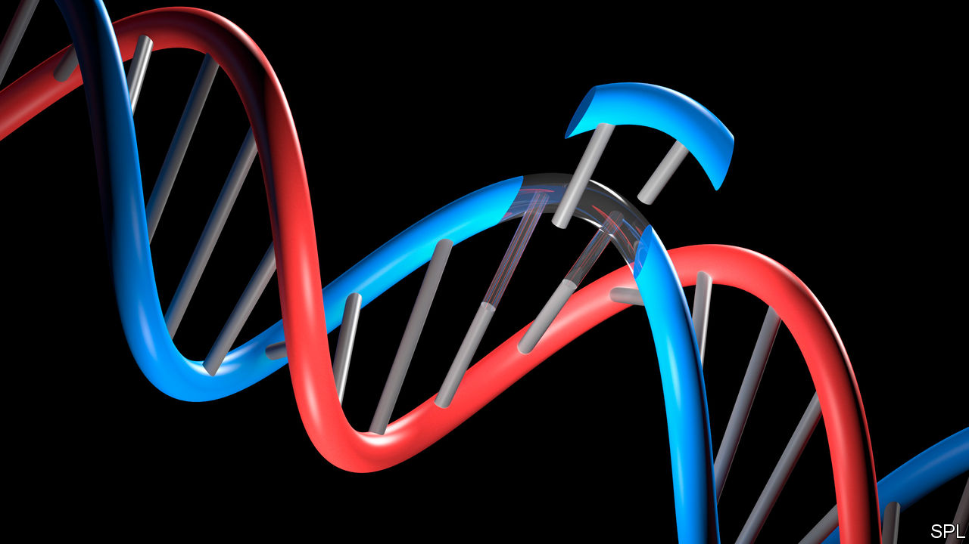

Print edition | Science and technology
The Economist, July 19th 2018
A GREAT deal rides on the accuracy of the gene-editing tool known as CRISPR-Cas9. Since its discovery in 2012 it has become popular for tinkering with genomes of all kinds, thanks to its ability to make editing cheap and easy. Firms such as CRISPR Therapeutics, Intellia Therapeutics and Editas Medicine have been built on the idea that it could be used to develop treatments for human diseases. Editas, based in Cambridge, Massachusetts, announced this year that it would work on five new human medicines over the next five years.
In China the technology is already in clinical use. In Hangzhou Cancer Hospital, for example, CRISPR-Cas9 is being employed to engineer immune-system cells removed from patients with cancer of the oesophagus. The hope is that when the engineered cells are returned to a patient’s body, the editing will have improved their ability to attack tumours. More studies involving human beings are expected in other countries for the treatment of beta-thalassaemia, a blood disorder, and Leber’s congenital amaurosis, a form of blindness. Further ahead, there is hope that CRISPR-Cas9 will help treat diseases such as AIDS, cystic fibrosis, Huntington’s chorea and Duchenne muscular dystrophy.
However, a study just published in Nature Biotechnology has found that when CRISPR-Cas9 is used to edit genomes, off-target DNA damage is more common than had previously been appreciated. This piece of research, co-ordinated by Allan Bradley of the Wellcome Sanger Institute, in Cambridge, England, looked at genetic changes in mouse and human cells across large stretches of the genome. In around 20% of cells examined, the use of CRISPR-Cas9 had caused unintended deletions or rearrangements of strings of DNA more than 100 base pairs long—and some as long as several thousand DNA base pairs. This raises the possibility that non-target genes or regulatory sequences could be affected by the editing process, a discovery which comes in the wake of other recent work which raised concerns that CRISPR-Cas9 gene-editing might trigger cancers. Cue investor panic and nosedives in the share prices of gene-editing companies.
Although Dr Bradley’s study certainly adds to concerns over the accuracy and safety of CRISPR-Cas9, it is by no means a show stopper. There are a number of caveats which may, in time, turn out to mean the findings are less concerning than they seem today.
For one thing, as Robin Lovell-Badge, an expert in the area who works at the Francis Crick Institute in London, observes, the study focuses on a form of genome-editing called “non-homology end joining”. This, he says, is known to be an untrustworthy approach compared with other ways of using CRISPR-Cas9. Moreover, the actual impact of the technique (and, indeed, of any gene-editing tool) will depend on the types of cells being edited and the nature of the changes being made.
Dr Lovell-Badge says that “it is not clear that the specific protocols used in the paper would relate much to any sensible use of genome-editing clinically”. In any case, CRISPR editing is a work in progress. New versions of the technique are being developed, with the intention of improving its accuracy and efficiency. Problems with one particular approach will doubtless act as a spur to innovation in others.
Dr Bradley’s study does nevertheless serve as a timely reminder of the need for caution when the technology is used in people. (It raises fewer concerns for gene-editing in research and for agricultural purposes such as crop improvements, where off-target effects are of less consequence.) Clinical applications will need to show that the only alterations are those that were intended.
In particular, the study raises the stakes for those who wish to make heritable changes to the human genome. This week a group of bioethicists concluded, in a report for the Nuffield Council on Bioethics, a think-tank in Britain, that in some circumstances the genetic engineering of human sperm, eggs or embryos could be morally acceptable. The technology is seen as potentially useful for removing heritable diseases or for reducing genetic predispositions to cancer.
But the report concluded that two principles should serve as a guide. One is that the changes brought about by gene-editing should not increase “disadvantage, discrimination or division in society”. The other is that such changes should be consistent with the welfare of the future person. For that to happen, any form of gene-editing needs to be demonstrably safe.
This article appeared in the Science and technology section of the print edition under the headline "Cutting to the truth"

Print edition | Science and technology
Red = terminology
Green = collocations

