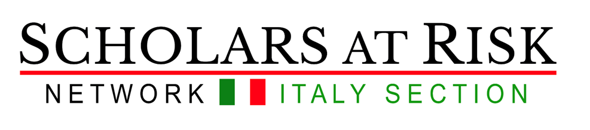

Advocacy Seminar on Academic Freedom 2021
SPGI Department, University of Padova
Laboratory for students (6 CFU)
Moodle:

Starting date: 23 February 2021 14.30
Application deadline: 22 February 2021
(Please apply using this online form by February 22)

Coordinators and instructors:
Claudia Padovani and Francesca Helm (SPGI Department, UniPD)
Various speakers (scholars and students, see schedule)

This laboratory is organized in collaboration between SPGI department and the international network Scholars at Risk.

The Advocacy Seminar Series on Academic Freedom provides university students with the opportunity to develop knowledge and skills through direct engagement on behalf of threatened members of the global higher education community facing unjust restrictions, prosecution, or imprisonment. Over the course of the seminar, students will gain a deep understanding of both the value of the academic freedom they enjoy, and the risks scholars and students around the world face in the pursuit of knowledge. Students organize awareness-raising advocacy initiatives and prepare an end-of-seminar report. In addition, students will have the chance to put their advocacy skills into practice at a number of public events.
Beside the class work, students are expected to successfully complete a SAR-produced MOOC on academic freedom titled ‘Dangerous Questions’ (video-lectures and tasks like commentaries, writing posts etc). This is part of innovative approaches to blended learning and is an integral part of the seminar.

This experiential laboratory is designed to give students a foundation in:
- Human rights research, standards, and mechanisms;
- International relations and academic freedom;
- Leadership and teamwork skills;
- Intercultural competences;
- Organization and networking for advocacy;
- Writing and public speaking for advocacy;
- Social media and online campaigning.

WHO CAN PARTICIPATE
The seminar is offered as a Laboratory activity for
students in the European and Global Studies EGOS degree (max 20 participants; priority is given to students enrolled in II year, then I year with a background in international studies)

The seminar also welcomes students from the Master degrees in
Strategie della Comunicazione (max 4 participants) and
Human Rights and Multilevel Governance (max 4 participants)
Relazioni Internazionali e Diplomazia (max 4 participants)

The foreseen activities require different disciplinary backgrounds, while offering an opportunity to experiment with the exchange of diverse knowledges and competences in the conduct of a practical project.
Collaborative interaction will also involve students and lecturers from various universities across the globe who are also taking part in SAR Advocacy Seminars, as well as guest speakers including representatives from NGOs, IGOs and organizations that are involved in Advocacy work.

The seminar is organized online (zoom platform) and held in English. Proficiency in other languages is welcome.

Students should participate in 80% of the activities.
Upon the successful completion of the activities students will be recognised 6 CFU (18 hours in class (online) + approx. 9 hours MOOC, 12 hours virtual exchange + approx. 15 hours in advocacy) + reading, group work, collaborative report writing.

Requirements: In due consideration of the fact that we will work on sensitive issues, what we expect from each other is motivation and the possibility to commit ourselves to the project until its completion. Further, students should consider that, while the coordinators will be there throughout to support the activities, autonomy and spirit of initiative in deciding how, where and with whom to carry advocacy. And writing the report, is highly important. Finally, a good knowledge of English (writing, speaking and listening) is essential. Credit-seekers and free-riders are discouraged to apply!!

This is a laboratory practice we do not expect non-attending students.

Please apply using this online form by February 22

For information and registration contact:
Claudia Padovani, claudia.padovani@unipd.it
Francesca Helm, francesca.helm@unipd.it.

DRAFT PROGRAM

Date | Topic | Time | Venue
Part I – Introduction: academic freedom and SAR seminar
23/02 | Introduction to SAR, SAR Italy, SAR@UniPD + European Coordinating Committee on academic freedom and the advocacy seminar  Speakers: C. Padovani and F. Helm with student alumni from previous seminar | 14.30-17.30 | Zoom meeting
01/03 | MOOC: Dangerous Questions: Why Academic Freedom Matters.  This MOOC is freely available here on the platform FutureLearn. Students register autonomously on the platform and in their own time follow the weekly activities on the platform, which include watching short videos, completing quizzes and contributing to forums. During the MOOC students will learn about:  - the meaning of academic freedom and related values and how these values interrelate  - challenges and threats to academic freedom in different contexts  - how academic freedom can be promoted and defended  - the importance of academic freedom to the development of society
09/03 | MOOC week 2
16/03 | MOOC week 3
30/03 | Adam Braver (Roger Williams University (USA) via zoom)  Practical: cases presentation, selection, group division (relevant to SAR Italy + European coordinating committee) | 14.30-17.30
06/04 | Academic freedom: a juridical approach  Speakers: S. Pennicino and human rights students (UniPd) | 14.30-17.30
07/04 | From research to practice: tools for advocacy  Address the connections between research and advocacy practice, starting from examples from different digital-related experiences:  - ‘Covid19 from the margins’ (BIgDataSur and Datactive)  - Data activism and legal approach  - Beautiful rising project and platform | 13:15 - 14.30 CET | This session is part of a different laboratory offered by DISLL on Public Value in Media and ICT
13/04 | Italian foreign policy and human rights: different perspectives.  Representatives from the Italian Diplomatic services, European parliament and Amnesty Italia. | 14.30-17.30 | Zoom meeting
Part II – Understanding the context and developing skills for research and advocacy - in collaboration with other teachers, classes and networks
20/04 | Contextual dimensions of academic freedom: testimonials from at-risk scholars | 14.30-17.30 | Zoom meeting
27/04 | Meetings with other advocacy seminars working on the same cases – international collaboration
04/05 | to be confirmed (tbc)
Part III – Advocacy: design and implementation
11/05 | tbc | 14.30-17.30 | Zoom meeting
18/05 | tbc
25/05 | tbc
Part IV – Advocacy initiatives and public events
June 2021 | First public presentation of the cases and advocacy activities on the occasion of SAR Italy Assembly (students to design campaigns activities to be disseminated across SAR Italy members)
 | Public presentations of the case(s) and advocacy activities
 | Swetaly - disseminate proposals for action across the Swetaly (Sweden and Italian network of universities and SAR sections)

